**Keeping Containers Running with Supervisor**

A supervisor process, or init process, is a program that’s used to launch and maintain the state of other programs. On a Linux system, PID #1 is an init process. It starts all the other system processes and restarts them in the event that they fail unexpectedly. This concept can be effectively applied inside containers to start and manage processes.

Using a supervisor process inside your container ensures that the container remains operational even if the main process—such as a web server—fails and needs to be restarted. Several programs can serve as supervisor processes inside a container. The most popular ones include init, systemd, runit, upstart, and supervisord.

**Example: Using Supervisord in a Container**

Suppose a company provides software that produces a full LAMP (Linux, Apache, MySQL, PHP) stack inside a single container. These containers use supervisord to ensure that all the related processes are kept running. Below is an example of how to use such a container.

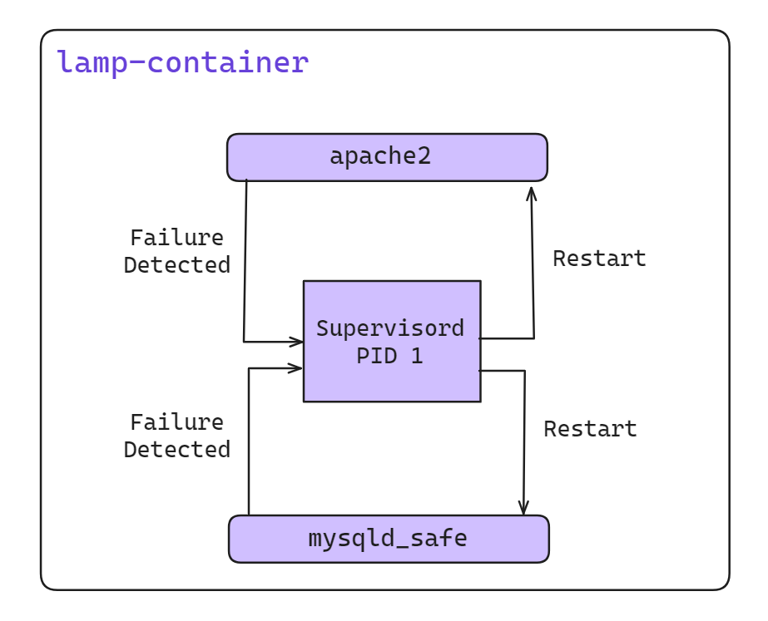

**Create a LAMP Docker Image**

Creating a LAMP (Linux, Apache, MySQL, PHP) stack image using supervisord allows you to manage multiple processes within a single Docker container. Here’s a step-by-step guide to create such an image:

**Step 1: Dockerfile Setup**

Create a Dockerfile to define your LAMP stack image. Here, we'll use supervisord to manage Apache and MySQL processes.

[ Docker file] [ docker code ase ai folder]

**Step 2: Supervisord Configuration**

**Create a supervisord.conf file in the same directory as your Dockerfile:**

[supervisord]

nodaemon=true

[program:apache2]

command=/usr/sbin/apache2ctl -D FOREGROUND

[program:mysql]

command=/usr/bin/mysqld_safe

**Step 3: Build and Run the Docker Image**

**Now, build your Docker image using the Dockerfile:**

docker build -t my-lamp-image .

**Starting the Container**

**And finally, run a container using your newly created image:**

docker run -d -p 80:80 -p 3306:3306 --name lamp-container my-lamp-image

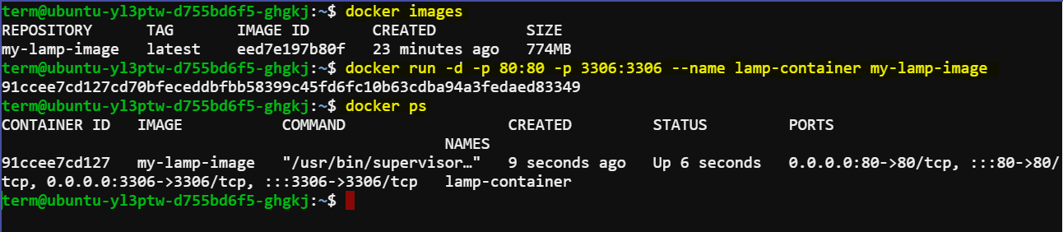

**Checking Running Processes**

**You can see what processes are running inside this container by using the docker top command:**

docker top lamp-container

The top subcommand will show the host PID for each of the processes in the container. You’ll see supervisord, mysql, and apache included in the list of running programs.

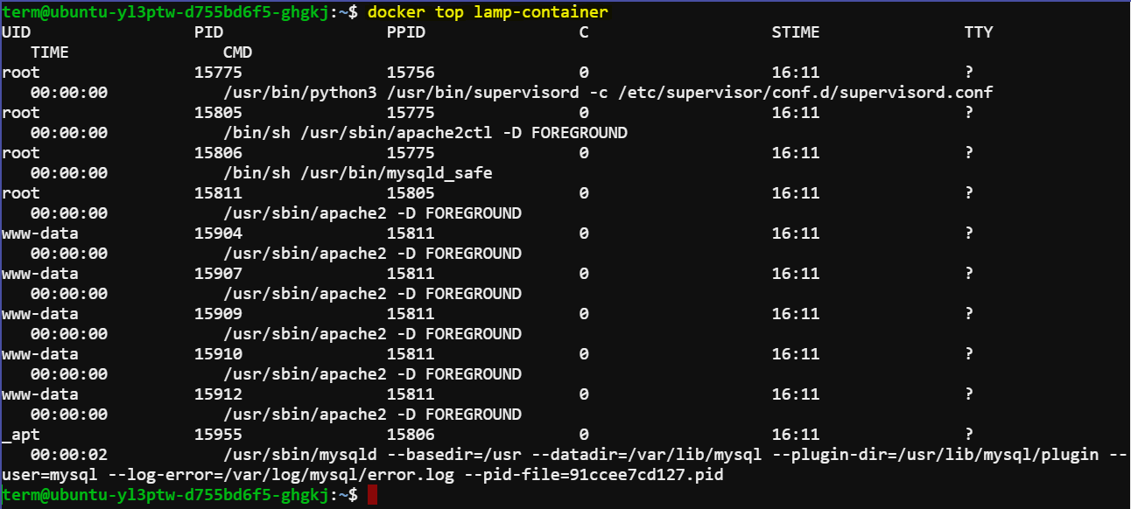

**Stopping a Process Inside the Container**

Now that the container is running, you can test the supervisord restart functionality by manually stopping one of the processes inside the container.

To kill a process inside a container from within that container, you need to know the PID in the container’s PID namespace. To get that list, run the following exec subcommand:

docker exec lamp-container ps

The process list generated will have apache2 listed in the CMD column:

PID TTY TIME CMD

1 ? 00:00:00 supervisord

433 ? 00:00:00 mysqld_safe

835 ? 00:00:00 apache2

842 ? 00:00:00 ps

The values in the PID column will be different when you run the command. Find the PID on the row for apache2 and then insert that for <PID> in the following command:

docker exec lamp-container kill <PID>

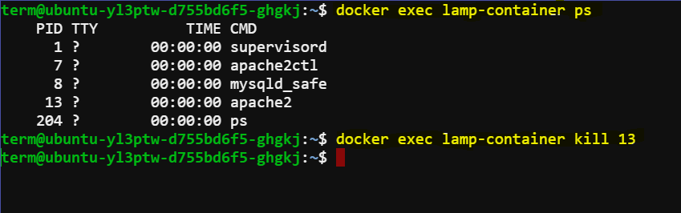

Running this command will execute the Linux kill program inside the lamp-container container and tell the apache2 process to shut down. When apache2 stops, the supervisord process will log the event and restart the process. The container logs will clearly show these events:

... exited: apache2 (exit status 0; expected)

... spawned: 'apache2' with pid 820

... success: apache2 entered RUNNING state, process has stayed up for > than 1 seconds (startsecs)

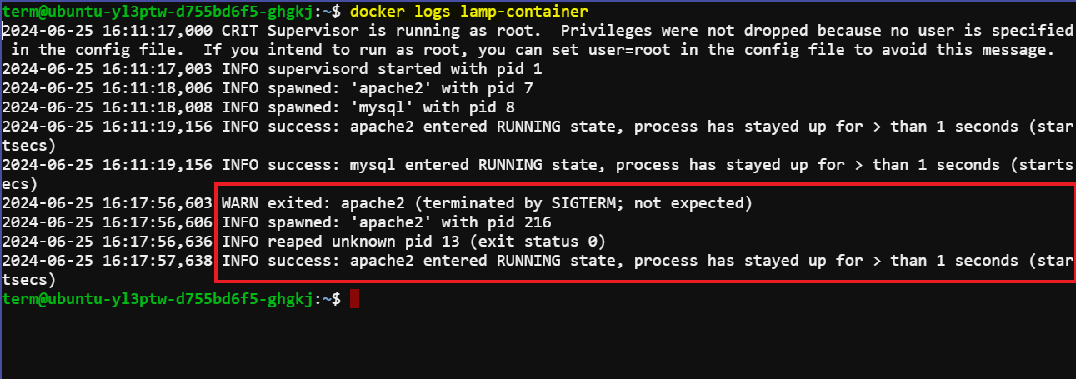

This ensures that the apache2 process is restarted by supervisord, thereby maintaining the container's functionality.

By using a supervisor process inside containers, you can manage and monitor the state of your applications, ensuring high availability and reliability of your services.